

[PPC-14121](https://dei-it.atlassian.net/browse/PPC-14121)

Εμπλουτισμός λιστών ΑΦΜ & Αρ. Παροχής με ΚΑΔ

Low Level design

contents

1 INTRODUCTION 3

2 Functional requirements 3

3 Technical requirements 3

4 Detailed Solution Architecture 4

4.1 Architecture Diagrams 4

4.1.1 Systems block diagram 4

4.1.2 Sequence diagrams 5

4.1.3 Deployment diagram 5

4.2 List of functions & systems 6

4.3 Data entities & data flows 6

4.4 Solution technologies 7

5 Detailed description of interfaces with other systems 7

5.1 Systems interfaces 7

5.2 Applications interfaces 7

6 Detailed description of system configuration 7

7 Detailed description of network configuration 7

8 Detailed Systems, Network & Information Security configuration 7

9 Test data / test methodology & Environments 8

9.1 Environments 8

9.2 Test Data 8

9.3 Security tests 8

9.4 Unit Tests 8

9.5 Systems integration tests 8

9.6 Stress tests / Performance tests 8

9.7 Acceptance Tests 8

10 Refferals / related documents () 8

DOCUMENT INFORMATION 9

# INTRODUCTION

The need to enrich VAT & Supply number (AADE activity code) for the purpose of identifying special professional categories eligible for subsidies.

# Functional requirements

Relevant BRD can be found here: [BRD](https://deidplr.sharepoint.com/teams/ITProjects/Shared%20Documents/14121-%20E%CE%BC%CF%80%CE%BB%CE%BF%CF%85%CF%84%CE%B9%CF%83%CE%BC%CF%8C%CF%82%20%CE%BB%CE%B9%CF%83%CF%84%CF%8E%CE%BD%20%CE%91%CE%A6%CE%9C%20%CE%BA%CE%B1%CE%B9%20%CE%91%CF%81.%20%CE%A0%CE%B1%CF%81%CE%BF%CF%87%CE%AE%CF%82%20%CE%BC%CE%B5%20%CE%9A%CE%91%CE%94/01%20-%20Proposal/Business%20Requirements%20Document/%CE%95%CE%BC%CF%80%CE%BB%CE%BF%CF%85%CF%84%CE%B9%CF%83%CE%BC%CF%8C%CF%82%20%CE%9A%CE%91%CE%94_PPC-14121_BRD.docx?web=1)

# Technical requirements

For the project, the following need to be implemented:

* An application service running on Azure that handles the VAT retrieval process from a csv, the communication with AADE for the information regarding the VAT and stores the results to a csv file.
* A Vault where the keys for the AADE API are stored
* Monitoring and Analytics modules.

In order to be supported the above functionalities, the Azure resources that are visible below have been provisioned on the existing subscription “Commercial Analytics”. Specifically, all the resources in order to be isolated have been grouped on “rg-comm-analytics-aade-prd-weu”.

|  |  |  |  |  |  |
| --- | --- | --- | --- | --- | --- |
| Type | Environment(s) | Role | Name | Region | Remarks |
| App Service Plan | Production | To host the business logic App Service | Asp-comm-analytics-aade-prd-weu | West Europe | P1V3, Linux, 2 vCPU, 8GB RAM, 250GB Remote Storage, Single Instance |
| App Service | Production | Host the business logic | App-comm-analytic-aade-prd-weu |  |  |
| Application Insights | Production | Logs and insights for the business logic App Service | appi-comm-analytic-aade-prd-weu | West Europe | Log Analytics ingestion mode, sampling disabled |
| App Service Slot | Production | Business logic App service alternative deployment slot | alt | West Europe |  |
| Key Vault | Production | Cloud service for securely storing and accessing secrets | Kv-comm-analytics-aade-d | West Europe |  |
| Virtual Network | Production | Isolated network provides private network on azure | Vnet-comm-analytics-aade-prd-weu | West Europe |  |

For the project’s scope, all the above mentioned resources have been provisioned only in production domain.

# Detailed Solution Architecture

The solution is very simple so a lot of the following sections are not applicable. Since the system comprises only of one block a lot of diagrams are the same

## Architecture Diagrams

### Systems block diagram

The system is the AADE service consumer block that handles the business logic.

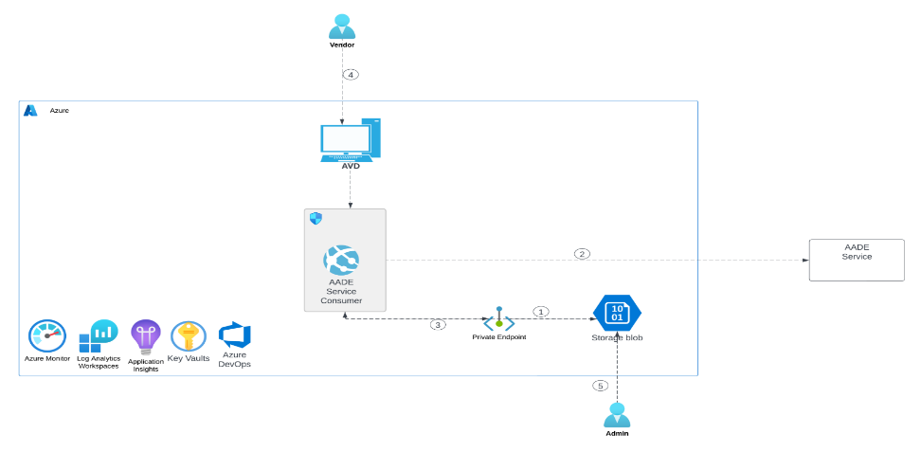

The blob service containers and storage are defined in the code as follows:

const blobServiceClient = new BlobServiceClient(`https://commercialsa.blob.core.windows.net/`,credential);  
const blobContainerClient = blobServiceClient.getContainerClient('wemetrixaade');  
const blockBlobInputClient = blobContainerClient.getBlockBlobClient('Input/KAD_TAXID_2023_12_27.csv');

Therefore the .csv file containing the related VATs is hardcoded in the application.

A typical input .csv file contains VATs (one per line):

0534433344,  
0534433444,  
...

A typical output .csv file is as follows:

**FEEDBACK I DO NOT HAVE THE END DATA**

### Sequence diagrams

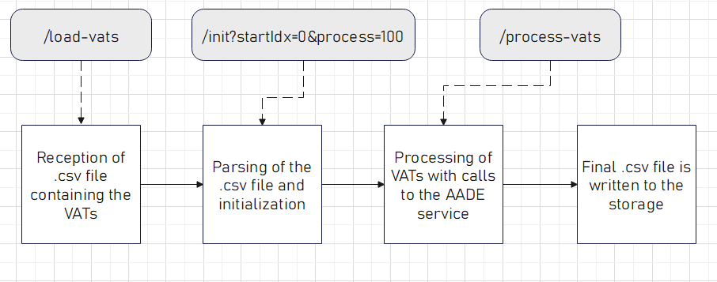

There is only one sequence which has the following steps:

1. AADE Service consumer receives .csv file with the VAT to be processed from the Storage blob. Call to the application’s endpoint: /load-vats. This endpoint loads the whole .csv file in memory
2. AADE Service consumer uses the .csv file to request from AADE Service to “KAD” related data for VATs contained in .csv file. Call to the application’s endpoint: /init?startIdx=0&process=100 where startIdx, startIdx+process define the range in lines in the file that holds the VATs that will be processed.
3. Processing begins. Call to the application’s endpoint: /process-vats to start the processing of the VATs.
4. AADE Service consumer writes the information retrieved to Blob Storage.

A .csv file named Output/startIdx_startIdx+process will be generated with the AADE service results

NOTE:

The vendor Implementation initiates this process in batches of x number of VATs based on startIdx,process paramters and then admin accesses to Storage Account to retrieve the results.

*In case of an error (the AADE API did not return the desired result:*

No extra action is performed. The system registers the VAT that caused the error to the CSV file and upon review of the file by the Data Analytics team, the problematic VATs may be reevaluated (in case there was an error of the API response and not an error of a VAT that does not exist in the AADE database since it refers to an individual and not a company)

### Deployment diagram

In terms of the project, in order the solution’s components to be deployed, new DevOps processes have been implemented. More specifically in regard to aade-analytics Function App:

* Respective codebase must be maintained in the existing Azure DevOps project ‘PPC – Commercial Analytics’, to new GIT repository of PPC ‘PPC-AADE-KAD’.
* Its functionality must be available at production environment only.
* Build pipelines must be implemented for production environment, that will be triggered by a GIT push operation at the corresponding branch.
* The development team will run build pipeline for production environment, in order to update the Function App source code.

Ν/Α

## List of functions & systems

|  |  |  |  |  |  |
| --- | --- | --- | --- | --- | --- |
| Function/capability | System/component | Existing/new | System owner/delivery team | Contact person | Tech spec or documentation ref |
| AADE communication | **AADE Service consumer** | new | WEMETRIX | Panagopoulos | - |
|  |  |  |  |  |  |

## Data entities & data flows

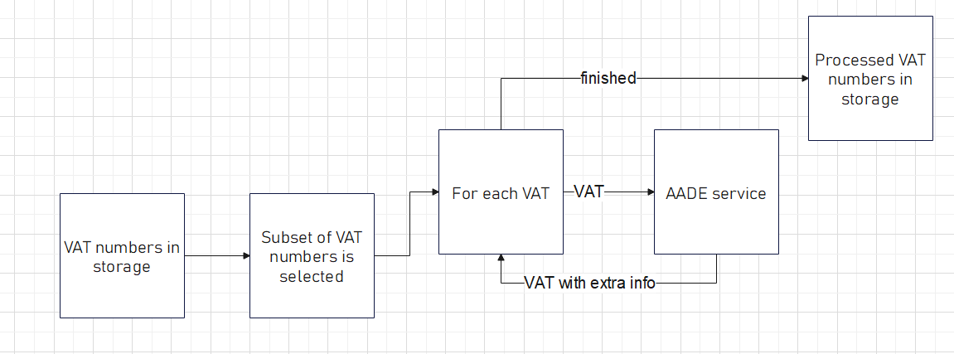

1. **AADE Service consumer receives .csv file with the VAT to be processed from the Storage blob.**
2. **AADE Service consumer uses the .csv file to request from AADE Service to “KAD” related data for VATs contained in .csv file**
3. **AADE Service consumer writes the information retrieved to Blob Storage.**
4. **Vendor Implementation initiates this process in batches of x number of VATs.**
5. **Admin accesses to Storage Account**

## Solution technologies

**An nodeJS/express application**

# Detailed description of interfaces with other systems

The only interface of the system is the one with AADE API. The endppoint is:

|  |  |
| --- | --- |
| <https://www1.gsis.gr/wsaade/RgWsPublic2/RgWsPublic2?wsdl> |  |

The wsdl describes fully the required input/output of the system

## Systems interfaces

N/A

## Applications interfaces

N/A

# Detailed description of system configuration

Apart from the initial deployment there is no extra need for any special configuration except the username/password loading to the vault for authentication with AADE

# Detailed description of network configuration

N/A

# Detailed Systems, Network & Information Security configuration

N/A

# Test data / test methodology & Environments

N/Α

## Environments

## Test Data

## Security tests

## Unit Tests

## Systems integration tests

## Stress tests / Performance tests

## Acceptance Tests

# Refferals / related documents ()

<ΗLD>

<SUGGESTIONS>

<DEMANDS>

<FEASIBILITY STUDY>

<CONTRACTS>

<OTHER PROJECT DOCUMENTS>

# DOCUMENT INFORMATION

|  |  |  |  |
| --- | --- | --- | --- |
| Title: | [Document Title] | | |
|  | | | |
| Start Date : | [YYYY.MM.DD] | Modify Date: | [YYYY.MM.DD] |
| Document Code: |  | Modify Number: | 1.0 |
| Document Rating:* | Εσωτερικό |  |  |

*Document Rating: Ungated, Interior, Confidential, Classified

|  |  |  |
| --- | --- | --- |
| Authors / Approvals | | |
|  | Name, Surname | Date |
| Author: |  |  |
| Ownership: |  |  |
| TEST: |  |  |
| Approval: |  |  |

|  |  |
| --- | --- |
| Receivers List | |
| Receivers | Activity* |
|  |  |
|  |  |
|  |  |
|  |  |

* Activity Types: Approval, Implementation, Update, Meeting Archiving, other [please describe]

|  |  |
| --- | --- |
| Revision History | Comments |
| 1.0 | Original Version |
|  |  |
|  |  |
|  |  |
|  |  |
|  |  |
|  |  |
|  |  |
|  |  |